Adding Dense Layers

|  |  |
| --- | --- |
| Team Id | PNT2022TMID39958 |
| Project | AI-Powered Nutrition Analyzer for Fitness Enthusiasts |

A dense layer is a deeply connected neural network layer. It is the most common and frequently used layer.

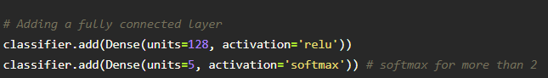

The number of neurons in the Dense layer is the same as the number of classes in the training set. The neurons in the last Dense layer, use softmax activation to convert their outputs into respective probabilities.

Understanding the model is a very important phase to properly using it for training and prediction

purposes. Keras provides a simple method, a summary to get the full information about the model and its layers.

